Lagged cross-correlation: AUDUSD and USDCHF
Method 12 / daily log returns / K_max=10 / Alpari D1 full available history

Study setup
Logical pair: AUDUSD , USDCHF
Broker symbols: AUDUSD_i , USDCHF_i
Snapshot: 2026-11-03_majors_alpari_D1
Timeframe: D1
Matched return window: 1999-01-05 to 2026-11-02 (UTC bar dates)
Matched return count n: 7200
Dropped unfinished last bar dated 2026-11-03 UTC after a tick-volume check against the prior complete day.
Lag definition: rho_X->Y(k) = Corr(x_t, y_{t+k}) on matched D1 bars
K_max = 10; headline lag k = 1 (both directions)
Complete matched rows (Excel): AUDUSD-USDCHF_Lagged_D1.xlsx
Complete matched rows (HTML table): AUDUSD-USDCHF_Lagged_D1_data.html

Method carried forward
Lagged cross-correlation measures Pearson correlation between matched daily log returns of close, ln(close_t / close_t-1), after shifting one series forward by k bars on the matched panel. Quotes are not inverted. rho_{X->Y}(k) = Corr(x_t, y_{t+k}) with n_k = n - k. K_max = 10 is fixed before estimation. The headline is the pre-specified lag k = 1 in both directions. k = 0 is the same-bar side check. The lag inside 1..10 with the largest absolute rho is stored as a descriptive column only; it is not a selected result. This is a linear screen, not proof of forecast edge, economic cause, or a trading signal.

Results (headline k=1)
rho_AUDUSD->USDCHF(1): -0.004580 (n=7199)
95% Fisher interval AUDUSD->USDCHF: [-0.027678, 0.018522]
rho_USDCHF->AUDUSD(1): 0.041640 (n=7199)
95% Fisher interval USDCHF->AUDUSD: [0.018557, 0.064679]
Same-bar rho(k=0): -0.380878
Largest |rho| among k=1..10 (descriptive only, not selected): AUDUSD->USDCHF k=9 rho=0.032025; USDCHF->AUDUSD k=1 rho=0.041640

CCF table
k | rho_AUDUSD_to_USDCHF | n_AUDUSD_to_USDCHF | rho_USDCHF_to_AUDUSD | n_USDCHF_to_AUDUSD
0 | -0.38087848 | 7200 | -0.38087848 | 7200
1 | -0.00458046 | 7199 | 0.0416401 | 7199
2 | 0.00941018 | 7198 | -0.02194203 | 7198
3 | 0.00457323 | 7197 | 0.00364251 | 7197
4 | -0.01715792 | 7196 | -0.02165963 | 7196
5 | -0.0286882 | 7195 | 0.02135255 | 7195
6 | -0.00130289 | 7194 | -0.007732 | 7194
7 | -0.0026768 | 7193 | 0.00099529 | 7193
8 | -0.01941846 | 7192 | -0.005559 | 7192
9 | 0.0320248 | 7191 | -0.00708658 | 7191
10 | -0.01136407 | 7190 | 0.01830849 | 7190

Conclusion
At the pre-specified lag k=1 for AUDUSD and USDCHF, rho_{AUDUSD->USDCHF}(1) = -0.0046 (n=7199) and rho_{USDCHF->AUDUSD}(1) = 0.0416 (n=7199). Same-bar rho(k=0) = -0.3809. Largest |rho| among k=1..10 is descriptive only: AUDUSD->USDCHF at k=9 (0.0320); USDCHF->AUDUSD at k=1 (0.0416). This is a linear screen, not forecast proof or a trading signal.

Charts
Daily closes

Daily log returns

CCF both directions k=0..10
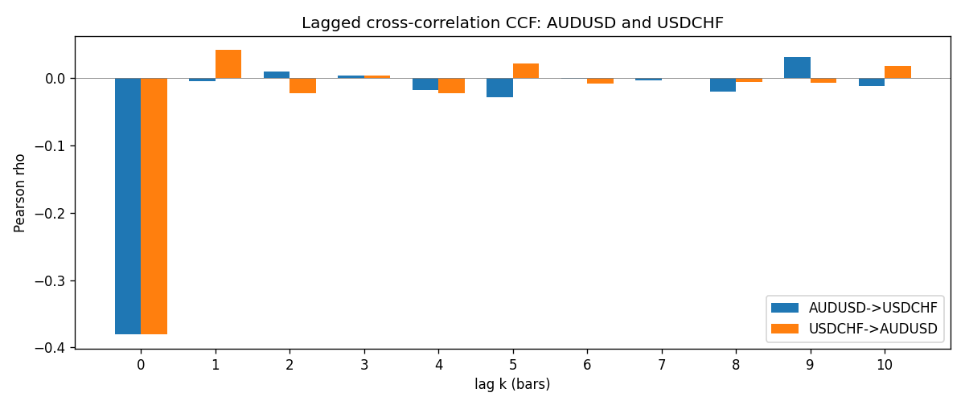

Data report
Every matched row is stored in the sibling Excel workbook named AUDUSD-USDCHF_Lagged_D1.xlsx (sheet matched_rows). The CCF sheet holds rho(k) for k=0..10. Embedding all rows as a Word table is impractical; the Word file holds column summaries and the first and last 15 rows.
Columns: time, AUDUSD_open, USDCHF_open, AUDUSD_high, USDCHF_high, AUDUSD_low, USDCHF_low, AUDUSD_close, USDCHF_close, AUDUSD_tick_volume, USDCHF_tick_volume, AUDUSD_spread, USDCHF_spread, AUDUSD_real_volume, USDCHF_real_volume, AUDUSD_log_return, USDCHF_log_return
Column summaries (matched calculation rows)
column | count | mean | std | min | 25% | 50% | 75% | max
AUDUSD_open | 7200 | 0.7519587 | 0.13528421 | 0.4785 | 0.6610975 | 0.731415 | 0.8091275 | 1.10284
USDCHF_open | 7200 | 1.0982244 | 0.25258622 | 0.72022 | 0.920675 | 0.990175 | 1.238625 | 1.8219
AUDUSD_high | 7200 | 0.75601148 | 0.13584385 | 0.4878 | 0.6647 | 0.734785 | 0.8152525 | 1.10795
USDCHF_high | 7200 | 1.1035234 | 0.25433538 | 0.73305 | 0.9249475 | 0.99377 | 1.2436 | 1.8313
AUDUSD_low | 7200 | 0.74790307 | 0.1345988 | 0.4775 | 0.65778 | 0.727495 | 0.804225 | 1.0975
USDCHF_low | 7200 | 1.0930985 | 0.25099871 | 0.08565 | 0.917415 | 0.98668 | 1.232725 | 1.8121
AUDUSD_close | 7200 | 0.75201172 | 0.13526687 | 0.4786 | 0.6612 | 0.731695 | 0.8091975 | 1.10169
USDCHF_close | 7200 | 1.0982149 | 0.25248642 | 0.72025 | 0.92097 | 0.990145 | 1.238625 | 1.8217
AUDUSD_tick_volume | 7200 | 77358.386 | 138142.18 | 109 | 5440 | 43334.5 | 71332.25 | 1234623
USDCHF_tick_volume | 7200 | 74199.562 | 113414.45 | 350 | 12776 | 40195 | 70261.25 | 858589
AUDUSD_spread | 7200 | 30.817222 | 16.887144 | 0 | 13 | 30 | 50 | 50
USDCHF_spread | 7200 | 26.104306 | 24.710129 | 0 | 5 | 16 | 50 | 100
AUDUSD_real_volume | 7200 | 5.2428187e+09 | 1.2538918e+11 | 0 | 0 | 0 | 0 | 3.811512e+12
USDCHF_real_volume | 7200 | 2.3239785e+10 | 8.9047261e+10 | 0 | 0 | 0 | 0 | 1.9331921e+12
AUDUSD_log_return | 7200 | 2.837e-05 | 0.00754598 | -0.08602525 | -0.00385535 | 0.0002835 | 0.00415437 | 0.0806166
USDCHF_log_return | 7200 | -7.168e-05 | 0.00659376 | -0.19545699 | -0.00336083 | 8.057e-05 | 0.00331954 | 0.09051364
First 15 matched rows (selected columns)
time | AUDUSD_close | USDCHF_close | AUDUSD_log_return | USDCHF_log_return
1999-01-05 | 0.6215 | 1.3724 | -0.00080418179 | 0.0039424743
1999-01-06 | 0.6289 | 1.3912 | 0.011836351 | 0.013605652
1999-01-07 | 0.6345 | 1.3782 | 0.0088650256 | -0.0093883841
1999-01-08 | 0.6347 | 1.3935 | 0.00031515916 | 0.011040268
1999-01-11 | 0.6393 | 1.4009 | 0.0072213815 | 0.0052963193
1999-01-12 | 0.6362 | 1.3872 | -0.0048608485 | -0.0098275602
1999-01-13 | 0.6312 | 1.3621 | -0.0078902098 | -0.018259701
1999-01-14 | 0.6295 | 1.3588 | -0.002696916 | -0.0024256692
1999-01-15 | 0.634 | 1.3834 | 0.007123101 | 0.01794228
1999-01-18 | 0.6346 | 1.379 | 0.00094592471 | -0.0031856384
1999-01-19 | 0.6392 | 1.3789 | 0.0072225153 | -7.2518946e-05
1999-01-20 | 0.64 | 1.3889 | 0.0012507819 | 0.0072259871
1999-01-21 | 0.6405 | 1.3836 | 0.00078094498 | -0.0038232689
1999-01-22 | 0.6327 | 1.3834 | -0.012252745 | -0.0001445609
1999-01-25 | 0.6302 | 1.3868 | -0.0039591468 | 0.0024546976
Last 15 matched rows (selected columns)
time | AUDUSD_close | USDCHF_close | AUDUSD_log_return | USDCHF_log_return
2026-10-13 | 0.69821 | 0.83244 | 0.0035007712 | -0.0024955621
2026-10-14 | 0.69715 | 0.83489 | -0.0015193215 | 0.0029388325
2026-10-15 | 0.69191 | 0.82676 | -0.0075447063 | -0.0097855323
2026-10-16 | 0.69426 | 0.82377 | 0.0033906408 | -0.0036230826
2026-10-19 | 0.6978 | 0.82677 | 0.0050859986 | 0.0036351779
2026-10-20 | 0.70022 | 0.8246 | 0.0034620426 | -0.0026281224
2026-10-21 | 0.70275 | 0.82427 | 0.0036066384 | -0.00040027413
2026-10-22 | 0.70186 | 0.82032 | -0.0012672558 | -0.0048036381
2026-10-23 | 0.70353 | 0.82497 | 0.0023765656 | 0.005652514
2026-10-26 | 0.70128 | 0.82649 | -0.0032032829 | 0.0018407959
2026-10-27 | 0.70245 | 0.82865 | 0.0016669876 | 0.0026100526
2026-10-28 | 0.70533 | 0.82781 | 0.0040915541 | -0.0010142111
2026-10-29 | 0.70245 | 0.82379 | -0.0040915541 | -0.0048680164
2026-10-30 | 0.70316 | 0.82438 | 0.0010102376 | 0.00071594559
2026-11-02 | 0.69971 | 0.81851 | -0.0049184984 | -0.0071459744

